Yuvan shankar K B

1P22MC062

KPR task sample screen shots:

1. Create a simple register page with the following fields [username, password], Create a login page to authenticate the registered users, On a successful authentication user must be redirected to a simple "Hello World" Page.

Starting the server:

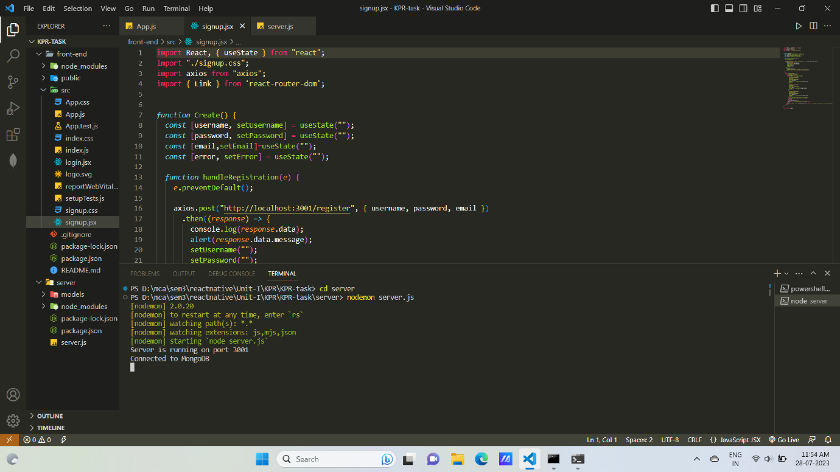

Starting the reactapp:

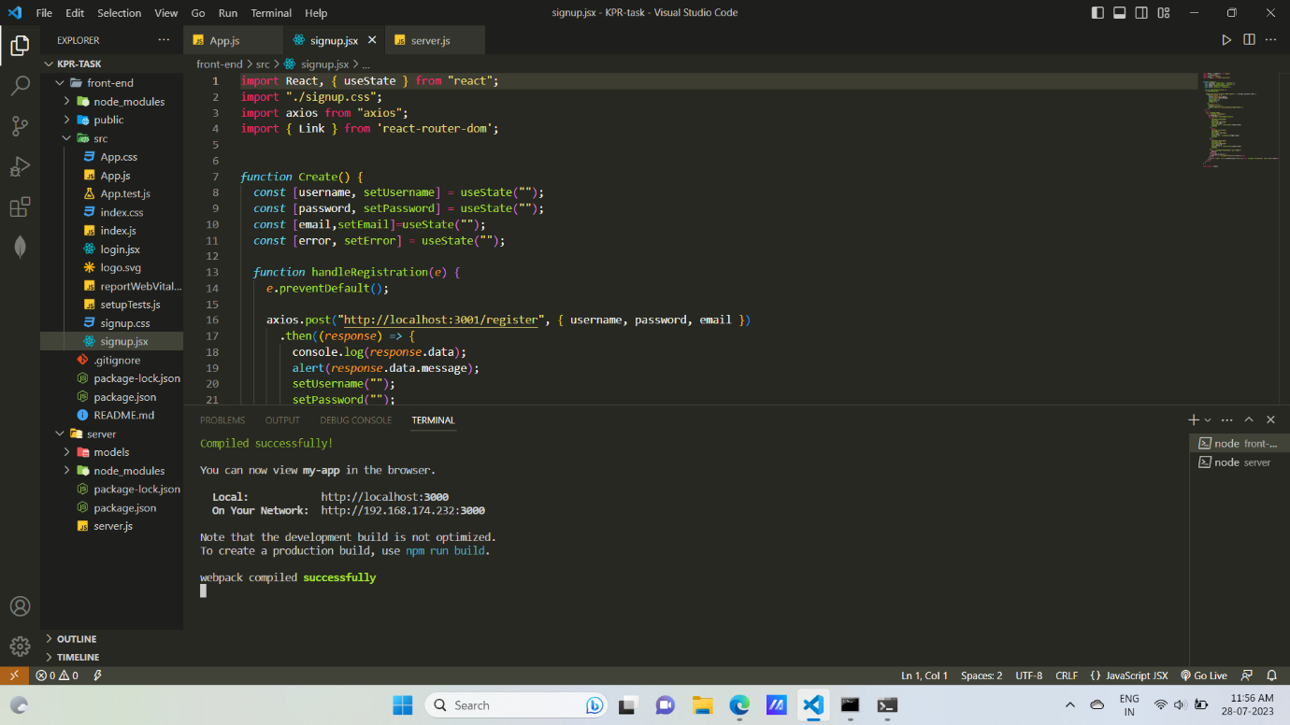

User interface in the browser:

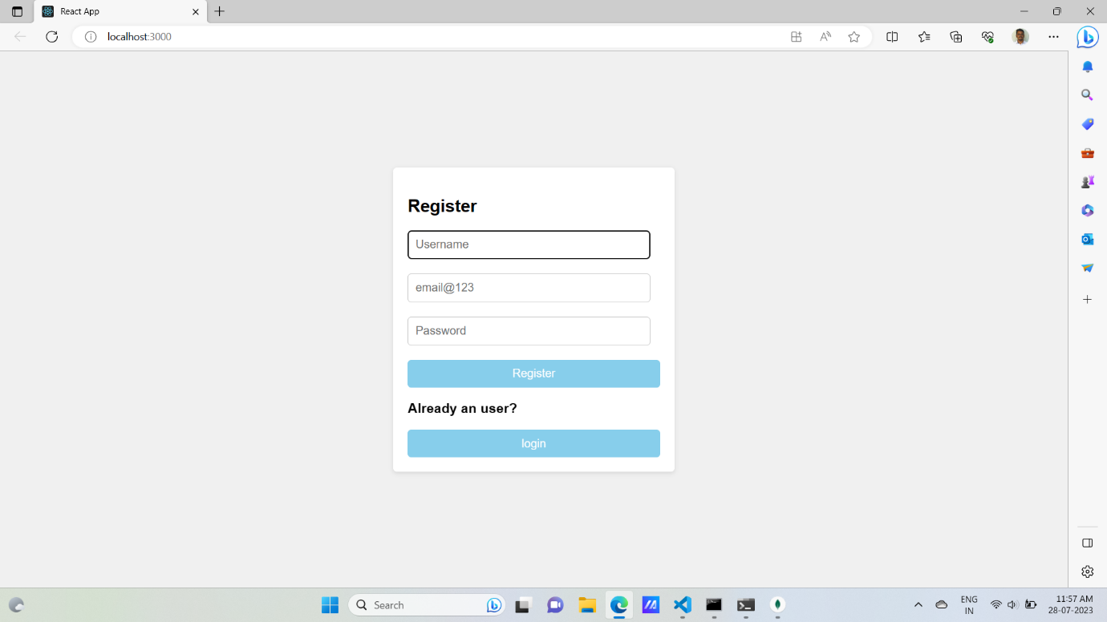

Entering the inputs inside required fields and creating an user:

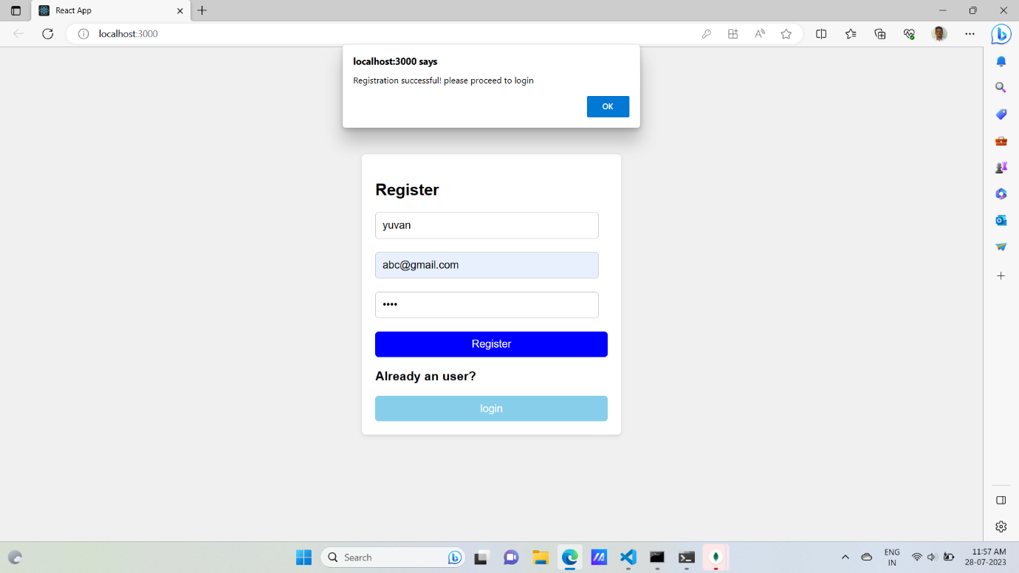

Login page using the registered email and password to login:

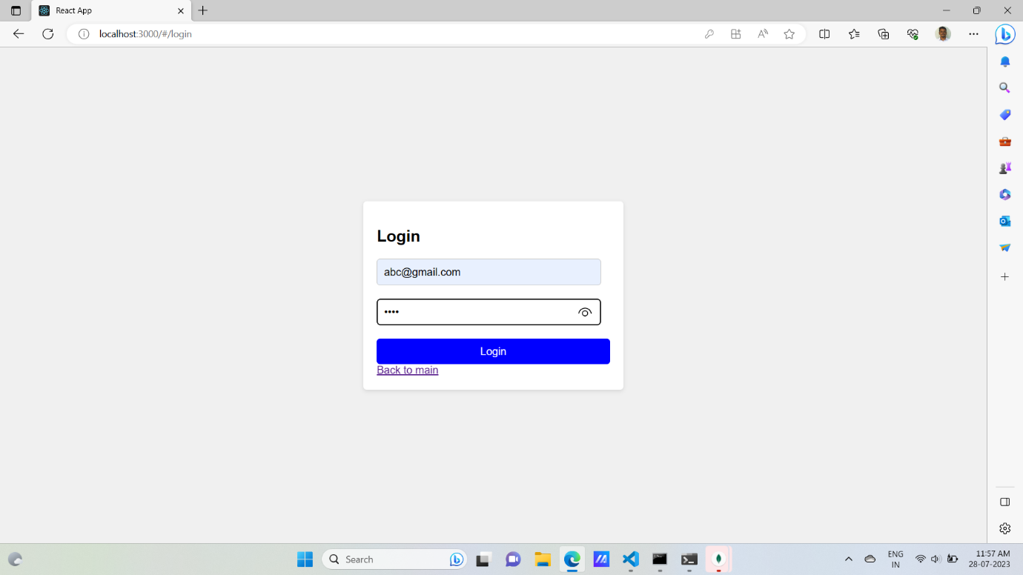

After successful login returns the hello message:

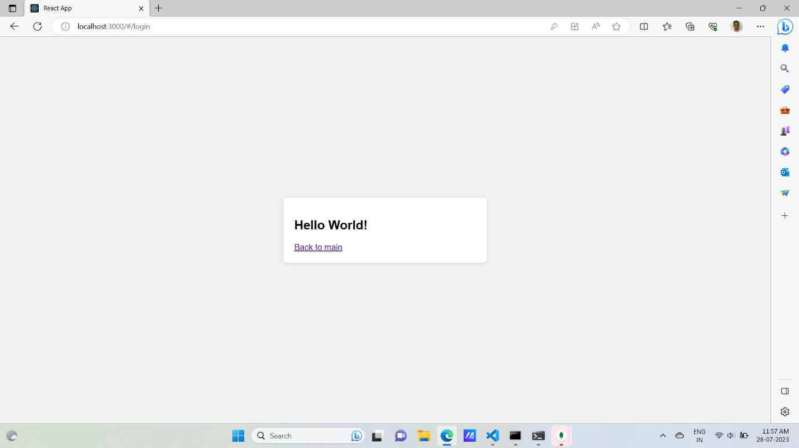

Again creating a new user with the existing username and email:

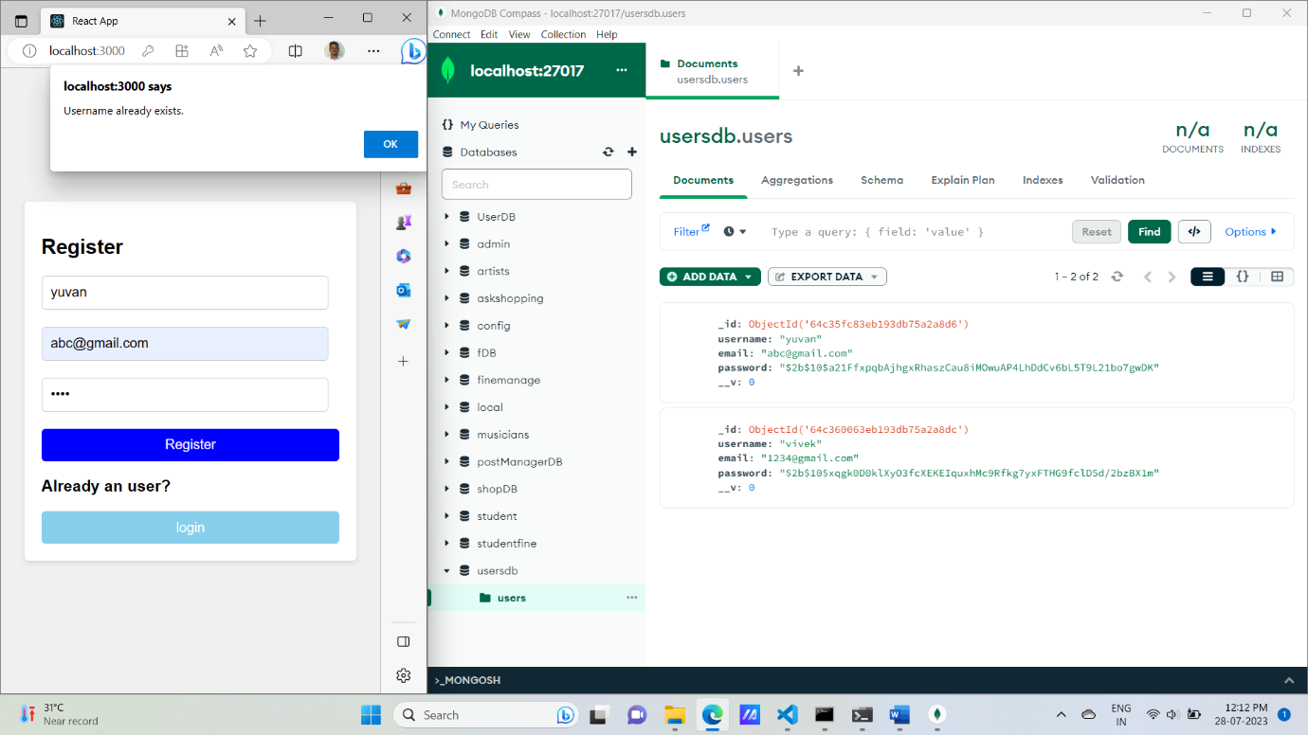

Login using wrong password or wrong email:

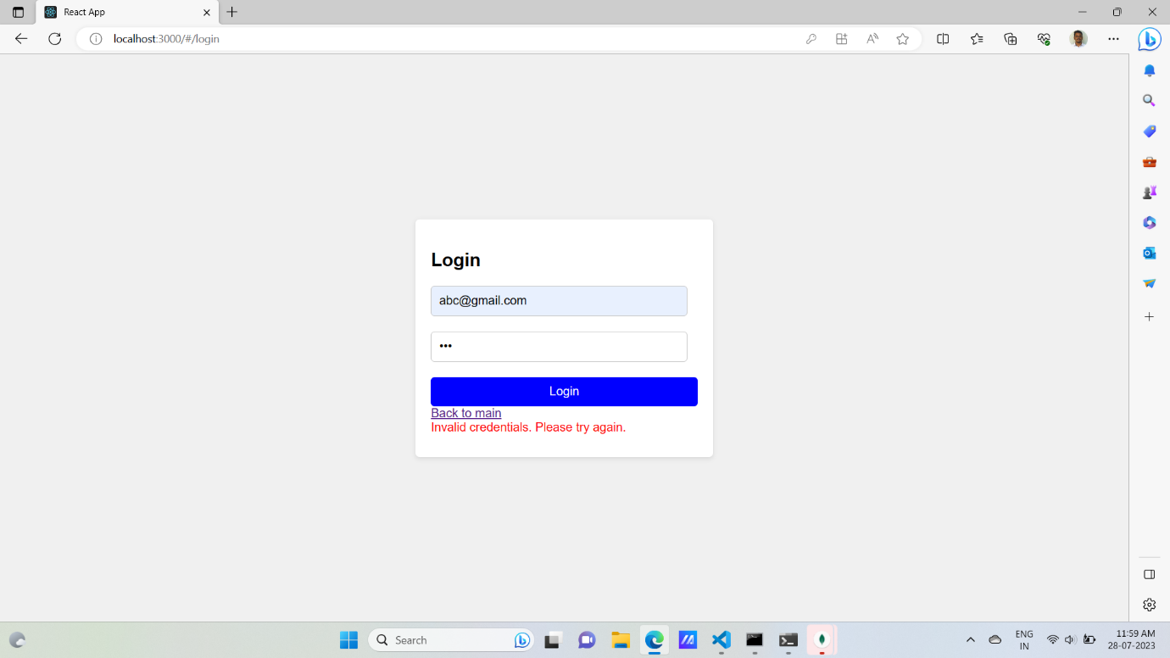

Mongodb database:

